Lutheran Social Services (LSS) in Thousand Oaks
Creating a Website
- How creating a website can help LSS to increase its social awareness and fundraising ability
  - Find data to show the impact of the company owned a website
  - How its can increase LSS’s social awareness and fundraising abilities
  - What are other pros and cons about creating a website for the company
- How to design and promote a website for LSS
  - What style the website should look like in order to attract more visitors (for example: simple or complex, friendly, or/and professional)
  - What features should be included on the website and why
    - Sample website: http://ning0218.wix.com/lssthousandoaks
  - How to increase the website visitors (e.g. directly email potential users, posters, or online advertisement)
    - Which one is the cheapest way and which one is more effective and efficient
- In what ways SSL can create its own website
  - Find a website builder (pros and cons)
  - Create by the company itself
    - For example, using free website builders, like Weebly and Wix (pros and cons)
Amazon Smile

Creating a Website for Lutheran Social Services in Thousand Oaks
LSS and Website Creation
Since Lutheran Social Services doesn't have it own website, it is important to know whether creating a website can influence company’s social awareness and fundraising significantly. This project discusses how creating the website can influence the average amount of fundraising and the visitors of the website in the nonprofit industry, the advantages and disadvantages to establish a website for the company, how to design and promote the website in order to attract the donors and visitor effectively and efficiently, and finally its analyzing which methods should the company use to build the website.
Statistics
Creating a website assists an organization in increasing its level of social awareness as well as its ability to raise funds. For any business, establishing a website is a social media strategy that is beneficial on a wide scale, such as in the case of Lutheran Social Services. The statistics provided for the Social Media Marketing Industry in 2011 show that 78% of companies that established websites foresaw an increase in the level of customer traffic by at least 10% (Deodato, 19), and Online giving has been steadily growing over the last couple of years, up 8.9% from 2013 to 2014 (Upleaf). This projection provides evidence that the creation of websites as a social media strategy is an important consideration for businesses seeking to enhance their social media presence. In addition, 51% of Millennials have visited a nonprofit's website (Corrado). Therefore, the millennials can be one of the key factors to increase the company’s fundraising ability and social awareness through online website, since the advanced in technology leads the information been delivered conveniently, and millennials are the largest users involving getting information through online. These estimates lead to the conclusion that any company with a website and those that seek to establish a website in the near future will see bigger wins by the close of year 2016. Companies that opt out of this strategy will miss out on the game-changing results.
How Websites Increase Social Awareness and Fundraising
The creation of a website for LSS results in an increased level of social awareness because it results in increased customer traffic. With the website in place, the company has the ability to reach a wide range of audiences in different geographic zones. This is a way of increasing the company’s brand awareness because new customers will be informed of the existence of the company as well as its brand and operation strategy. With accurate transfer of the identified message, the company’s ability to raise funds will also be enhanced. People from different parts of the world will have the chance to help raise funds without appearing physically at the company’s location.
Pros and Cons of Establishing a Website
Despite the increased level of brand awareness as well as fundraising capacities, LSS may face other advantages and disadvantages associated with the establishment of a website. For example, an increased customer base drives the level of sales higher. Generally, the establishment of a company’s website creates an online interface where customers from different locations can interact with the company, learn about its products and services, and even become loyal customers. With this in mind, customers from any part of the world can become loyal to a company, in turn benefiting the company through an increased level of sales (Benlian, 227).
One of the disadvantages associated with the creation of a website is the cost involved. Website design is a costly process because it is time-consuming, requires professional skills, and is a collaborative process. Incidentally, it is almost impossible to design an effective website in one day (Sachau & Hutchinson, 1038). Additionally, this process calls for a business to hire a qualified website developer who will create an effective website that runs properly. However, this does not guarantee that the final site will run as anticipated or be unique due to a chance that the site may appear similar to that of other participants in the industry. Furthermore, most websites require constant upgrades. This means extra costs for the company.
Designing and Promoting a Website for LSS
Website design can be conducted with the assistance of other software development programs such as Java and MySQl. There are several sites with easy-to-use inbuilt formats that allow a company to identify a theme than suits its needs and later modify it to ensure that the company’s brand and strategy are implemented within the website. The LSS company website can be promoted through the use of social media marketing tools such as Search Engine Optimization (SEO). Through SEO, the company will incorporate the use of keywords to ensure the company appears first among the search results on search engines (Sachau & Hutchinson, 1040).
To attract a wider audience, a company will often create a simple website. A simple website is user-friendly and effective because visitors will be able to identify what element of the site is located where. Additionally, simple websites are easy to load because they contain standard font sizes with limited images, allowing the site’s resolution to be appropriate for faster loading. Furthermore, simple websites will make it easier for visitors to navigate the site and obtain the correct information about the company and all that they seek to achieve (Hao-Chun Chuang, 1160). With the identified features, the site will be friendly enough to ensure that visitors spend time there without becoming bored or wondering what the site is about.
The LSS company website will contain several features. One of the important aspects is the company’s brand name, which is Lutheran Social Services. With the brand name, site visitors will know if they are visiting the correct company’s site or not. An “about” tab will also be included to provide a definition of the company’s brand strategy, including the services and products that it delivers to the market. In this case, the information that the company is not-for-profit will be provided. The fact that the company mostly deals with foster children and the homeless will also be indicated under this section. There will also be 2–3 images outlining the company’s activities. Having a limited number of images ensures that the site loads faster due to the limited resolution. Other features contain events and links to various social media pages, making it easier for donors to learn about the company. Because donors care about how the organization uses their money, the website could include financial reports. It may have video and photo features to illustrate examples of the services provided by LSS. Additionally, the website will include a section outlining its online donation process as well as an interface where visitors can donate through the site. The picture below is a rough sample website that our team designed for LSS through the Wix website builder.
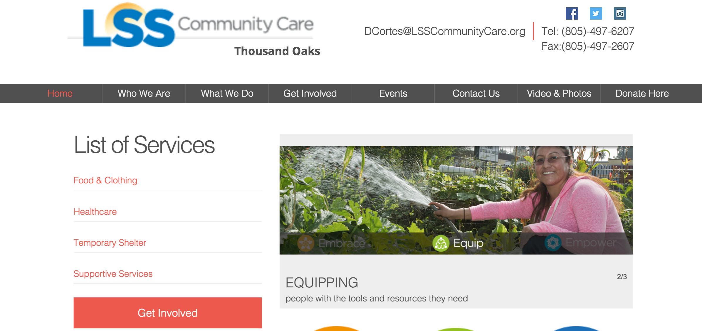
To increase the number of site visitors, the company will engage in online advertisement beyond the use of SEO. With online advertisements, the company will place advertisements about what it offers on various online pages such as on Facebook. This will be followed by a link that directs the visitors to the company’s website. The use of online advertisement is regarded as the cheapest way of advertising that may be quite effective (Jayaram et al., 120). Placing adverts on online pages can last for a considerate amount of time, making the advert effective and efficient.
Creating the Website
LSS can create its website through the use of website building applications such as XAMPP. This particular builder is advantageous because the created site will not only look professional but will also have several functionalities that cannot be achieved by free website builders. In contrast, the use of Xampp as a website builder may disadvantageous because it is time-consuming. As is, the builder must implement many codes to incorporate and design all aspects of the site. It is also costly, as the company is required to employ a qualified software developer with the requisite knowledge to manipulate code to develop an effective website.
As an alternative to finding a website builder, LSS can also create its website on its own. To achieve this, the company could consider the use of free website builders available online such as Weebly. The identified online builder is advantageous because it has code already inbuilt, making it easier for any person to edit the provided sample to suit the needs of the company. With Weebly, the company will first identify the appropriate theme that goes along with the company’s taste and preferences and later edit it to include the requisite data and information. The use of Weebly is not only less demanding and time-consuming, but also less expensive. One of the disadvantages of using the free website builder is that it limits the user on various scales. For example, the user may find it difficult to change the general look of the site based on how the code was first established to create the available sample site.

Works Cited
Benlian, Alexander. "Web Personalization Cues And Their Differential Effects On User Assessments Of Website Value." Journal Of Management Information Systems 32.1 (2015): 225-260. Business Source Complete. Web. 4 Mar. 2016.
Corrado, Taylor. "30 Stats Nonprofits Should Know When Engaging Millennials." 30 Stats Nonprofits Should Know When Engaging Millennials. Web. 4 Mar. 2016.
Deodato, Joseph. "Evaluating Web-Scale Discovery: A Step-By-Step Guide." Information Technology & Libraries 34.2 (2015): 19-75.Academic Search Premier. Web. 4 Mar. 2016.
Hao-Chun Chuang, Howard. "Impact Of Value-Added Service Features In E-Retailing Processes: An Econometric Analysis Of Web Site Functions." Decision Sciences 45.6 (2014): 1159-1186. Business Source Complete. Web. 4 Mar. 2016.
Jayaram, Dureen, Ajay K. Manrai, and Lalita A. Manrai. "Effective Use Of Marketing Technology In Eastern Europe: Web Analytics, Social Media, Customer Analytics, Digital Campaigns And Mobile Applications." Journal Of Economics, Finance & Administrative Science 20.39 (2015): 118-132. Business Source Complete. Web. 4 Mar. 2016.
Sachau, Lori, and Susan Hutchinson. "Trends In Culturally Relevant Interface Design Features For Latino Web Site Users."Educational Technology Research & Development 60.6 (2012): 1033-1050. Professional Development Collection. Web. 4 Mar. 2016.
"Online Fundraising Trends." Upleaf. Web. 4 Mar. 2016. <https://upleaf.com/nonprofit-resources/online-fundraising/online-fundraising-trends>.
Zech, Charles, William Wagner, and Robert West. "The Effective Design Of Church Web Sites: Extending The Consumer Evaluation Of Web Sites To The Non-Profit Sector." Information Systems Management 30.2 (2013): 92-99. Business Source Complete. Web. 4 Mar. 2016.

